Test task
Software Architecture
Table of contents

1. Requirements 3
2. Use-Case View 4
3. Design View 5
3.1. News section 5
News List view 5
News View 8
News Edit 10
4. Logical View 12
5. Implementation View 13

Requirements

Main system configuration requirements:

- Operating system: MS Windows XP;
- Technology: J2EE/J2SE (JSP, Servlets);
- Application Server: Jakarta Tomcat;
- Database: Oracle;
- Browser compatibility: Internet Explorer with JavaScript enabled;
- Abstraction Layer: Spring
- MVC pattern: Struts 1.x;
- Data Access: JDBC

Functional requirements summary:

- interface internationalization using resource files;
- data output formatting, localization;
- forms data validation;

Implementation requirements:

- Sun java coding conventions;
- Struts taglibs usage in JSP pages, minimal scriptlets usage;
- Pages layout using Struts Tiles.
- Support for English and Russian languages.
- Spring-Struts integration.

Use-Case View

Main Use-Case
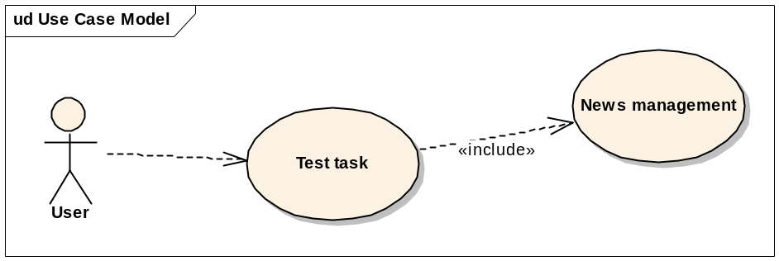

News Management Use-Case
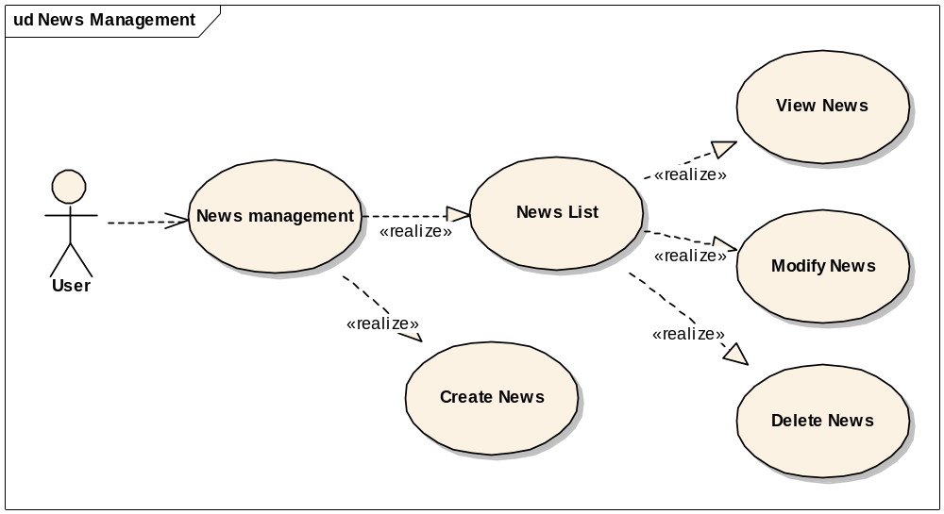

Design View

News section

News List view

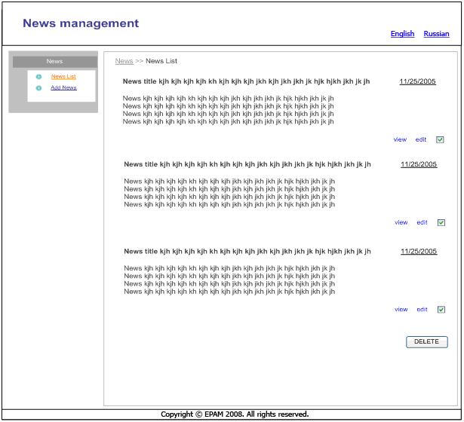

News List – Description
Description | Screen, where all news can be seen.

News List – Data Fields
Tab Order | Name | Label Name | Element Type | Default Value | Valid Values | Maximum Length | Required (Y\N)
1 | Lbl001 | # | Label | Number in list |  | N/A | N/A
2 | Lbl002 | Title | Label | News title |  | N/A | N/A
3 | Lbl003 |  | Label | News brief
4 | Lbl003 | Date | Label | News date |  | N/A | N/A
5 | Cb001 | Select | Checkbox | Not checked | Checked, not checked | N/A | N/A

News List – Links and Buttons
Link Name | Label Name | Result
Lnk001 | view | Go to the View News screen.
Lnk002 | edit | Goes to the Add\Edit News screen.
Btn002 | DELETE | Apply BR#1, show confirmation message, then delete selected (with <Select> checkbox checked) News

News List – Business Rules and Requirements
Requirement | Description
1 | At least one check box must be selected to allow user to delete news(s). If no check boxes selected, then show error message E04.
2 | News list is ordered by date (default order).

News View
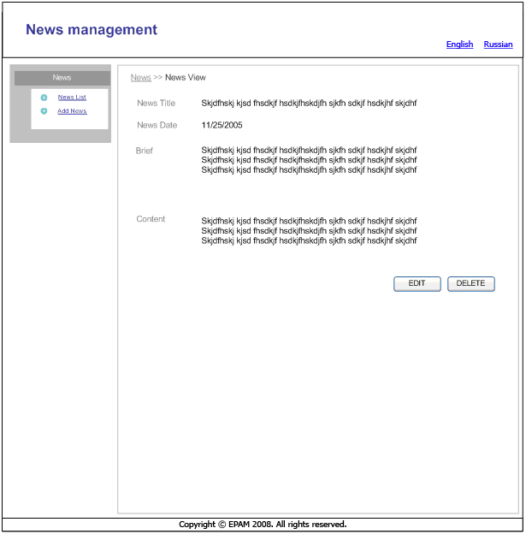

News View – Description
Description | This screen allows user to view news item data.

News View – Data Fields
Tab Order | Name | Label Name | Element Type | Default Value | Valid Values | Maximum Length | Required (Y\N)
1 | Lbl001 | Title | Label |  |  | N/A | N/A
2 | Lbl002 | Date | Label |  |  | N/A | N/A
3 | Lbl003 | Brief | Label |  |  | N/A | N/A
4 | Lbl004 | Content | Label |  |  | N/A | N/A

News View – Links and Buttons
Link Name | Label Name | Result
Btn001 | Edit | Goes to the Add\Edit News screen.
Btn002 | Delete | Shows confirmation message E08, then deletes news and goes to “News List” screen.

News View – Business Rules and Requirements
Requirement | Description

News Edit
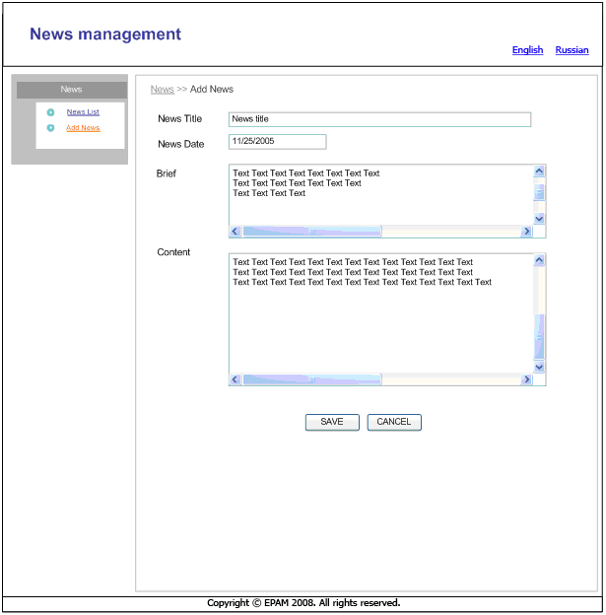

News Add\Edit – Description
Description | Screen for adding new news or editing selected.

News Add\Edit – Data Fields
Tab Order | Name | Label Name | Element Type | Default Value | Valid Values | Maximum Length | Required (Y\N)
1 | Txt001 | Title | Textbox | None |  | 100 | Y
3 | Txt003 | Date | Textbox | Current date | Date format strings | 10 | Y
4 | TxtA001 | Brief | Textarea | None |  | 500 | Y
5 | TxtA002 | Content | Textarea | None |  | 2048 | Y

News Add\Edit – Links and Buttons
Link Name | Label Name | Result
Btn001 | Save | Applies BR#1; then stores or updates news and then goes to “News View” screen
Btn002 | Cancel | Discards changes and goes to “News List” screen (if form opened from list view) or “News View” screen (if form opened from view screen).

News Add\Edit – Business Rules and Requirements
Requirement | Description
1 | All required fields must be filled in. If they are not, then validation message is shown.

Logical View

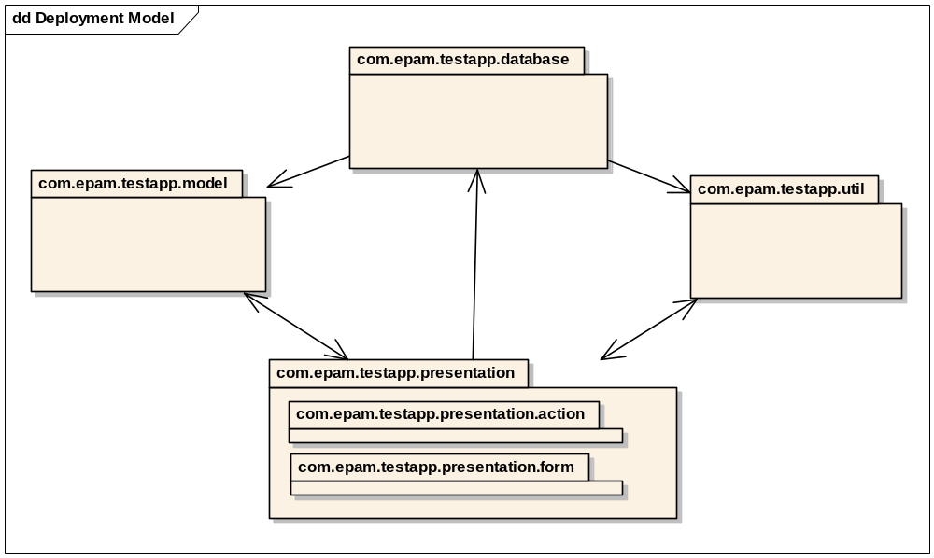

Implementation View
